Terraform Task-2

Task Description:

Create 2 EC2 instances on 2 different regions and install nginx using terraform script.
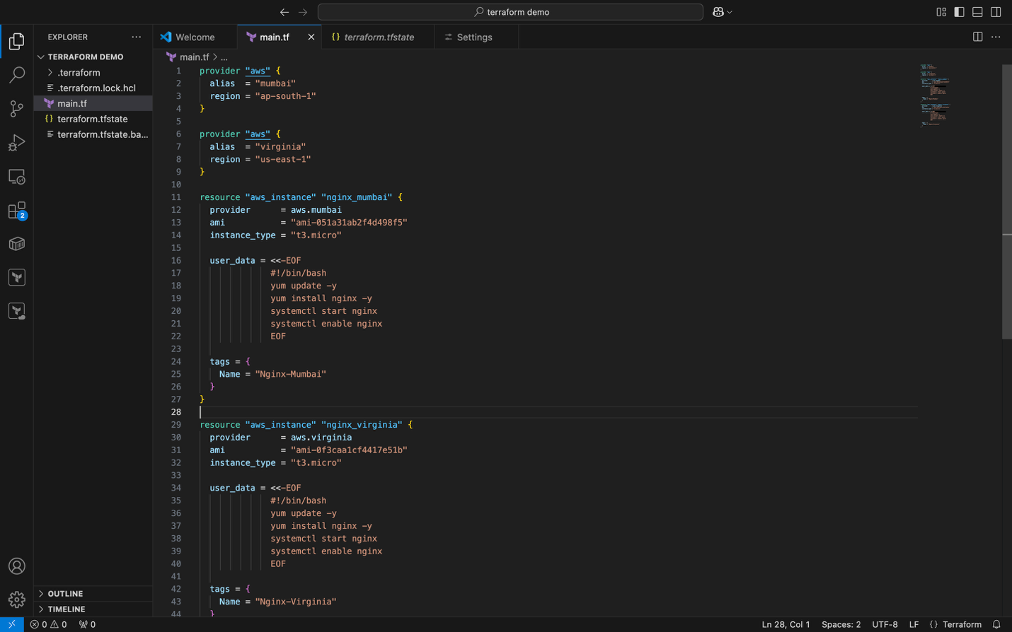
EC2 INSTANCE IN N.VIRGINIA
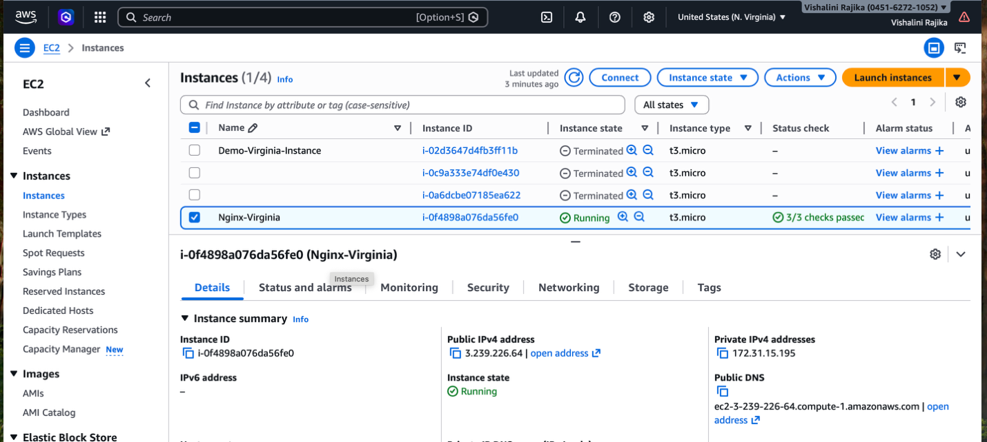
NGINX INSTALLED IN N.VIRGINIA EC2 INSTANCE
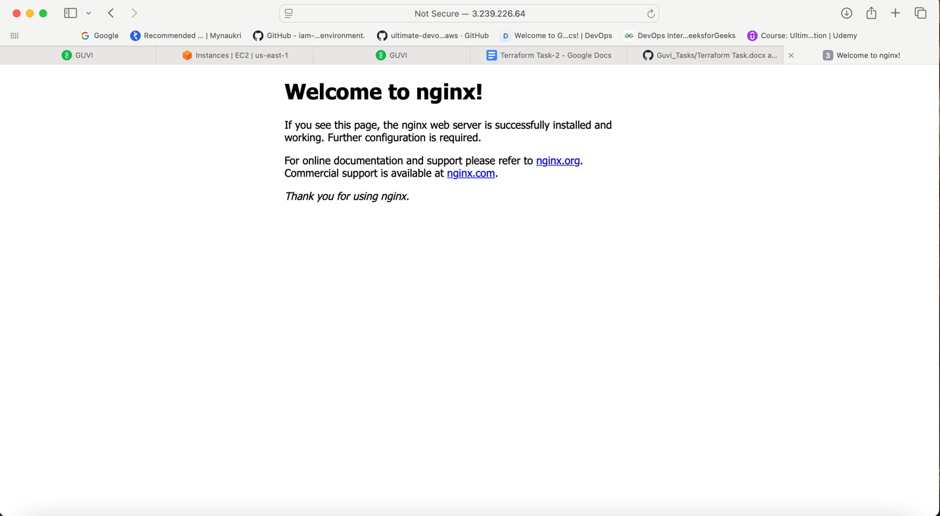
EC2 INSTANCE IN MUMBAI
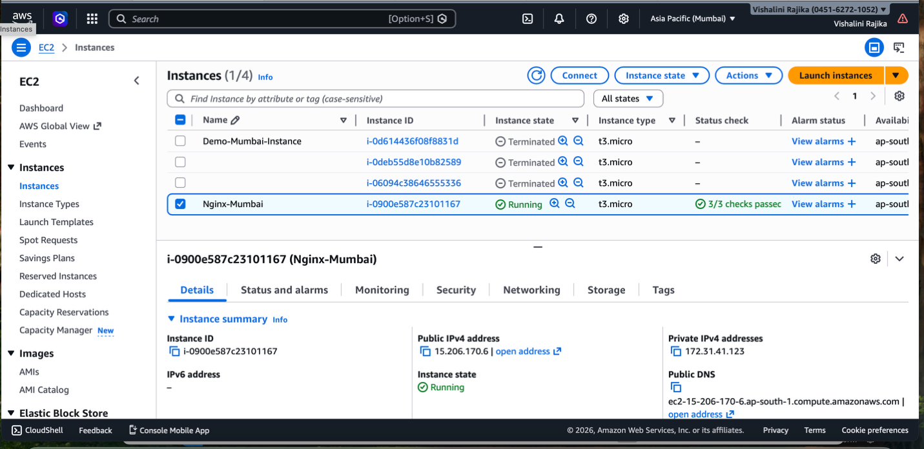

NGINX INSTALLED IN MUMBAI EC2 INSTANCE
